OVERVIEW

This document provides instructions for creating a billing event to recognize the revenue for a specific fund number using either the user interface for a single event or the billing events spreadsheet for bulk events. This document also provides instructions for using the ADFDI spreadsheet for uploading bulk expenses. The ADFDI spreadsheet required for bulk transactions can be found here: SinaiCloud - 09232024-files - All Documents (sharepoint.com)

AUDIENCE

- Central Finance Manager/Staff

Manage Revenue Upload – Using the User Interface

 Please note: This process should only be used when uploading one or two events.

- In the Menu Ribbon, select Contract Management.
- Select Revenue.

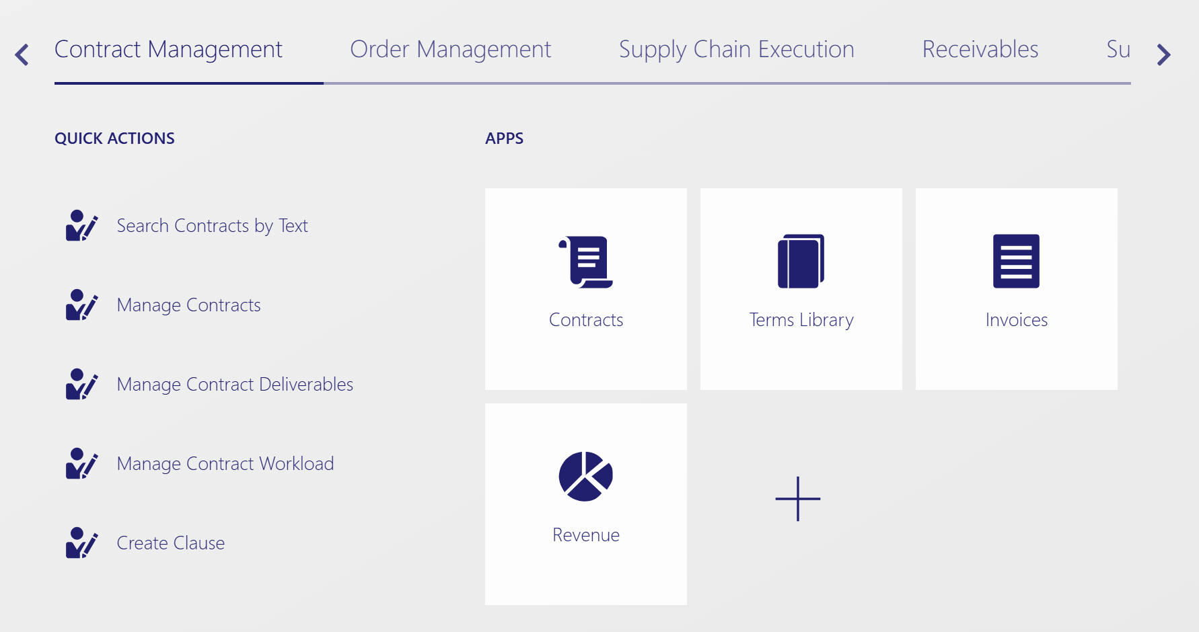
2
1

- On the Overview page, select the Task icon, then select the Manage Events link in the Review and Adjust section.

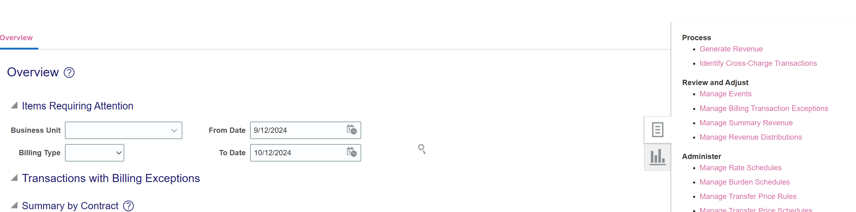
3

- In the Search Results section, select the Actions drop-down arrow and select Create.

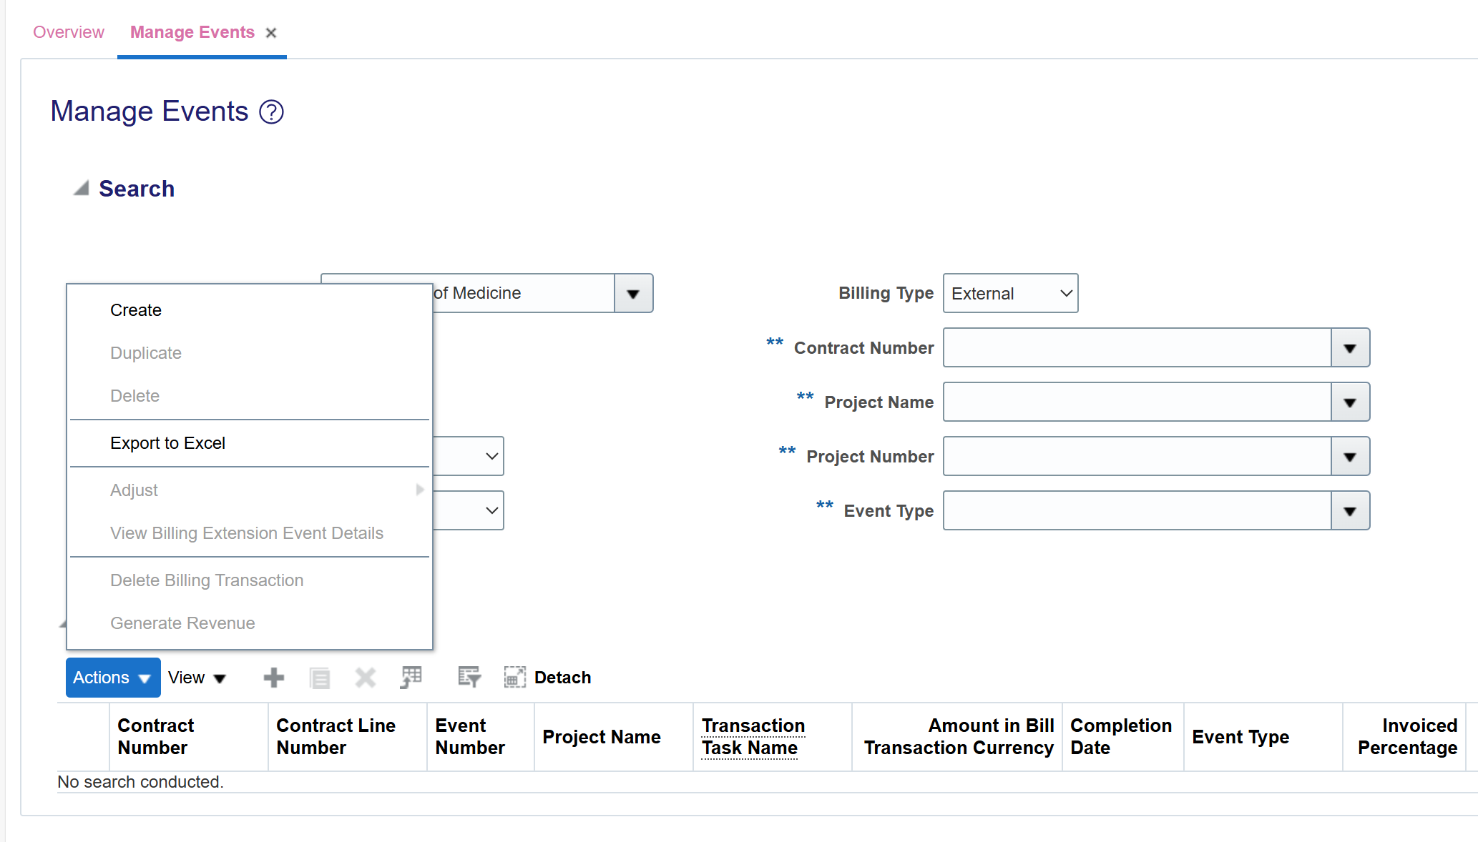
4

- Complete the following required fields:
- Business Unit
- Contract Number
- Contract Line
- Event Type/Description
- Amount in Bill Transaction Currency
- Organization

- Select the Save and Close button. This transaction has been completed.
6
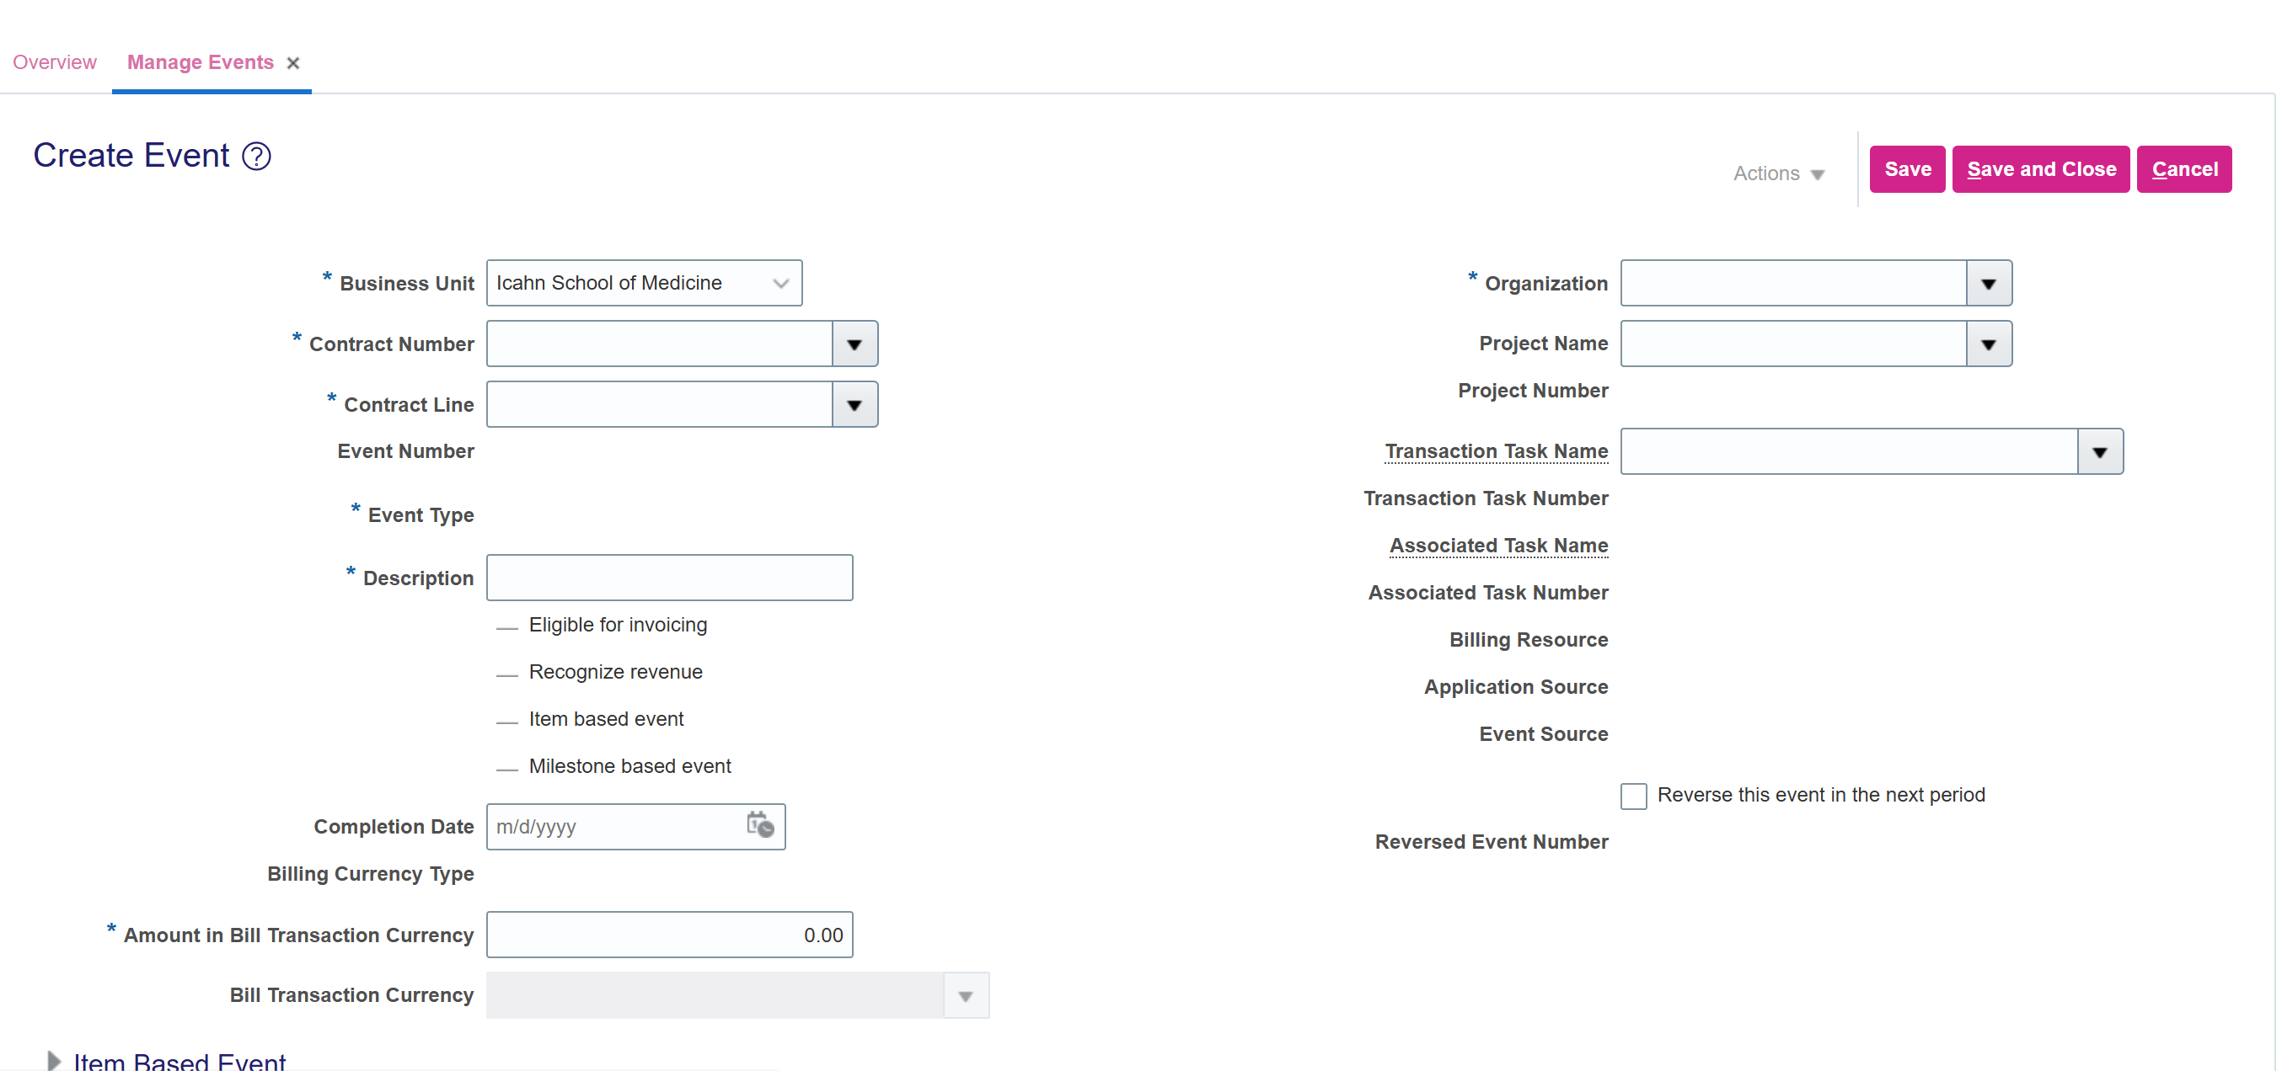
5

Please note: An Award's contract is created by associating it with an Award's project. Revenue methods are created and assigned to the Revenue Plan, which is further linked to the Award Contract. Both the Award and the Project should be active, and the Event type must be set up. Ensure that the Accounting Period is in an Open state.

Manage Revenue Upload – Using the Billing Events Spreadsheet

Please note: This process should be used to upload bulk events.

- In the Project Billing Events spreadsheet, complete the following required fields:
- Contract Type
- Contract Number
- Contract Line Number
- Event Type
- Bill Transaction Currency
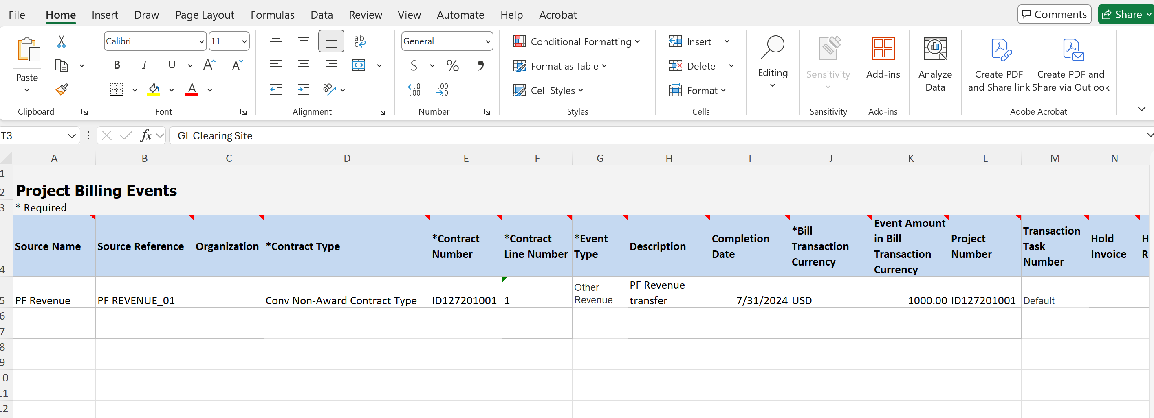
1

Please note: Required fields are marked with an asterisk (*), which signifies that the spreadsheet can be submitted with just those fields completed. However, the business requires every field to be completed where information is available so be sure to complete as many fields as possible.

Please note: Once you have entered the required information, be sure to remove the column headers in Row 3 before continuing the transaction.

- Select the Instructions and CSV Generation tab at the bottom of the spreadsheet.

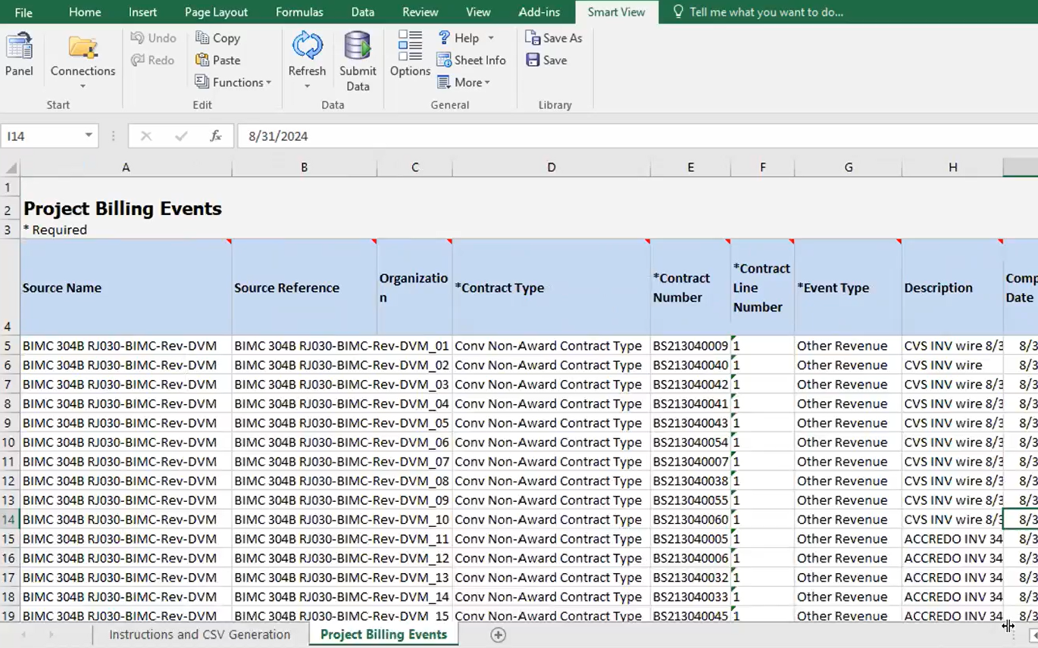
2

- Select the Generate CSV File button.

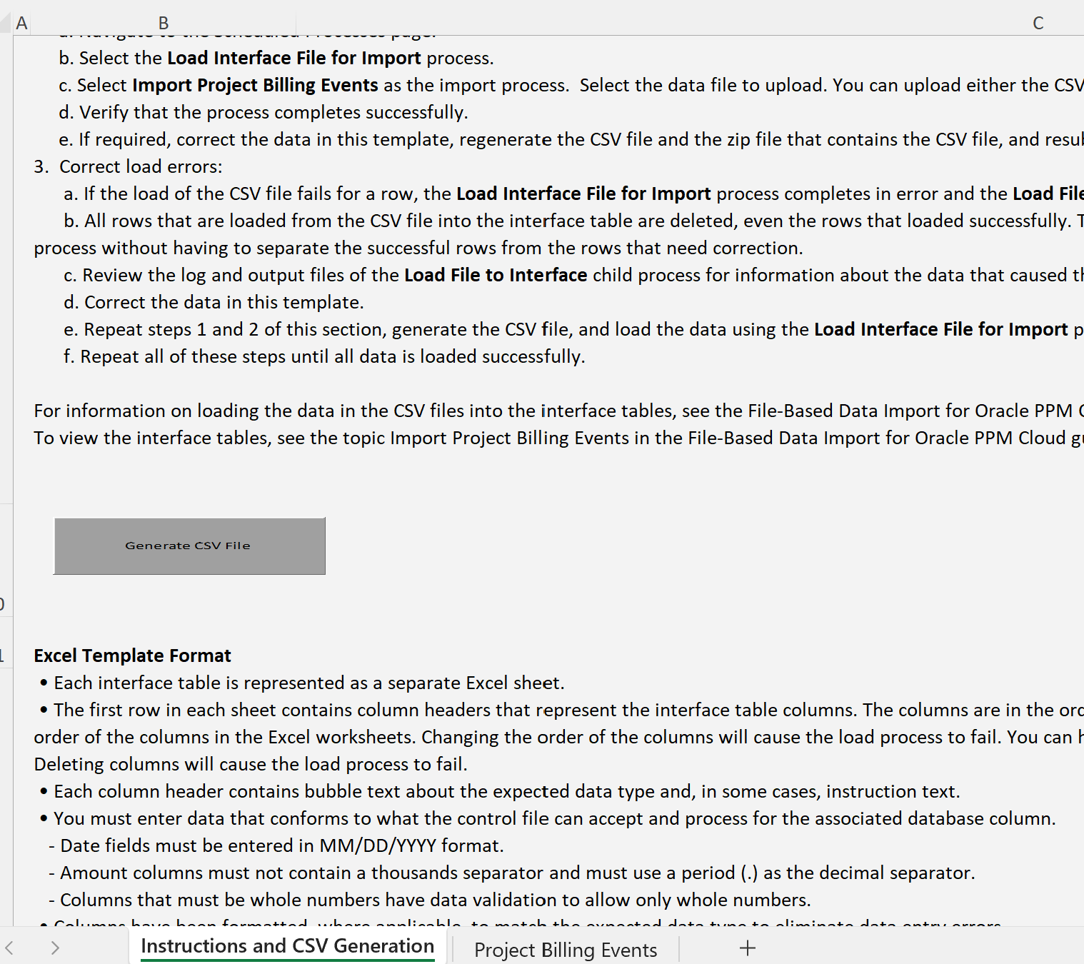
3

- Select the appropriate file location and click the Save button.

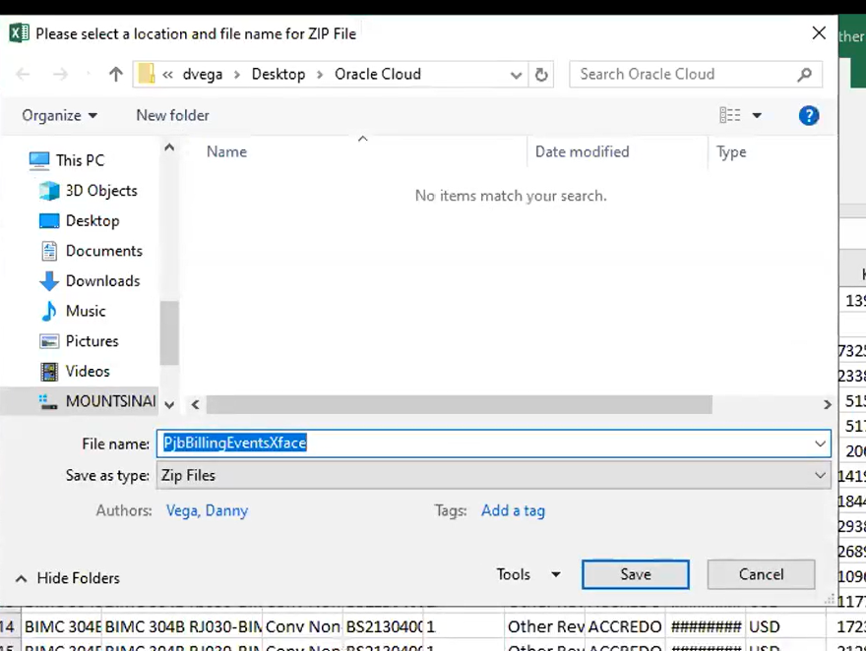
4

- The CSV file is saved as well. Select the same location where the spreadsheet is saved and click the Save button.

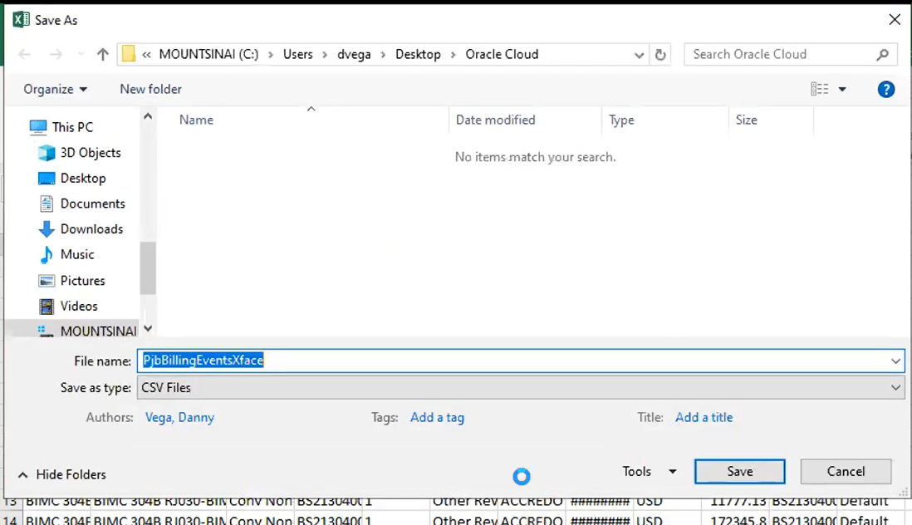
5

- Select the OK button.

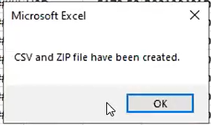
6

- In the Menu Ribbon, select Contract Management.
- Select Revenue.
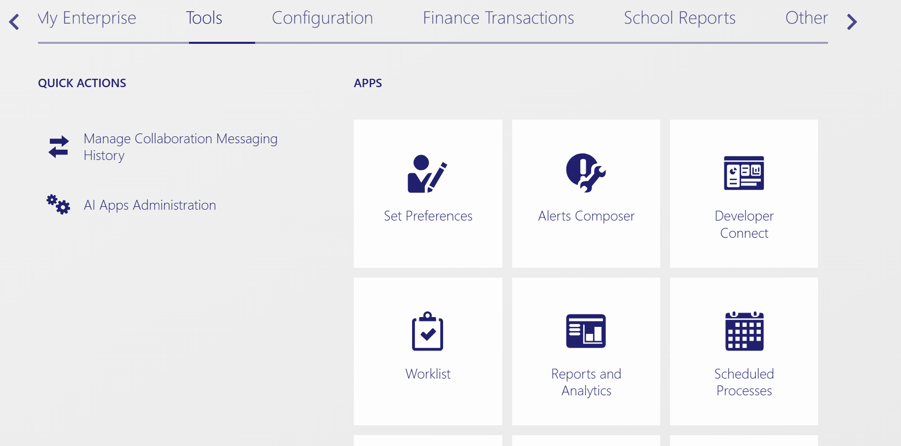
8
7

- Select the Schedule New Process button.
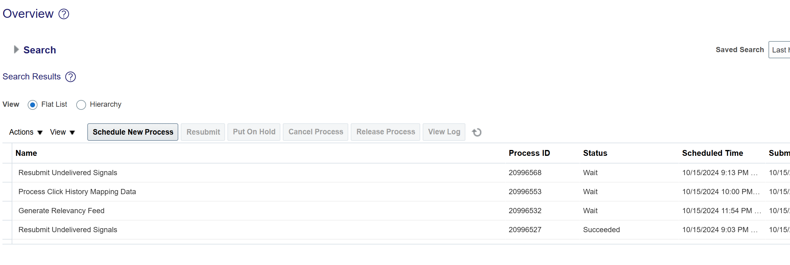
9

- Select the drop-down arrow and select Load Interface File for Import from the list.
- Select the OK button.
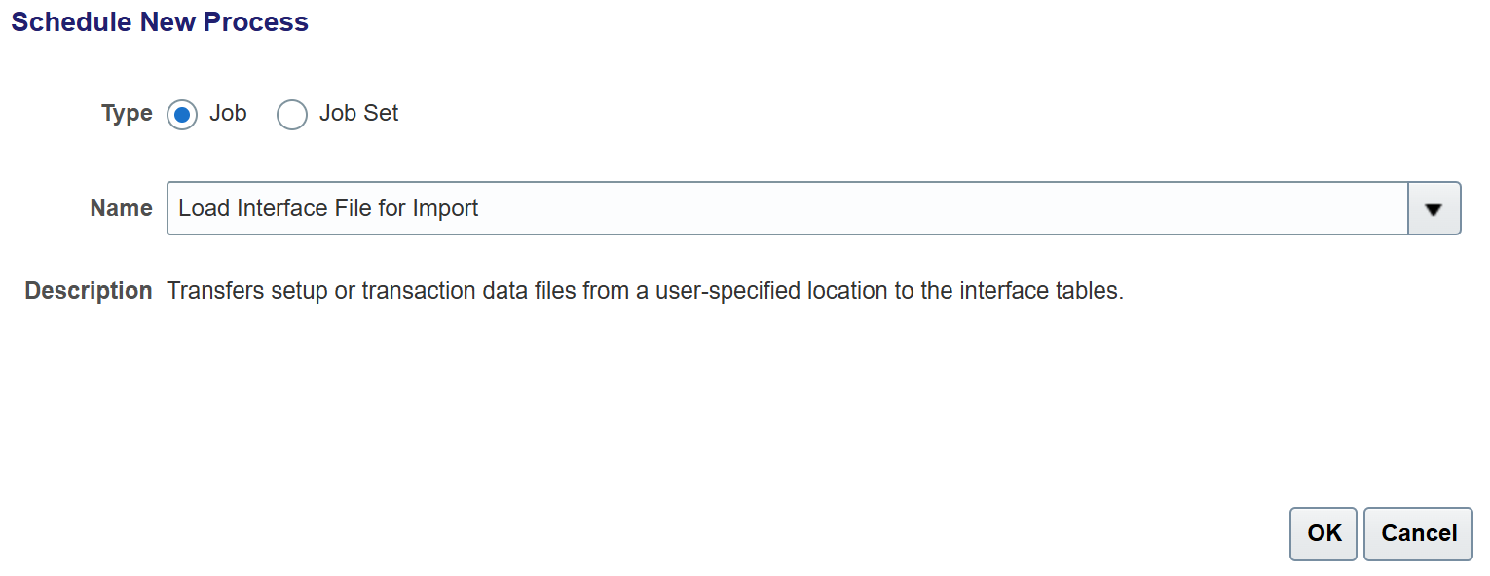
10
11

Please note: You may need to use the Search feature after selecting the drop-down arrow to find the load interface line item.

- Select the drop-down arrow in the Import Process field and select Import Project Billing Events from the list.
- Select the drop-down arrow in the Data File field and select Upload a new file.
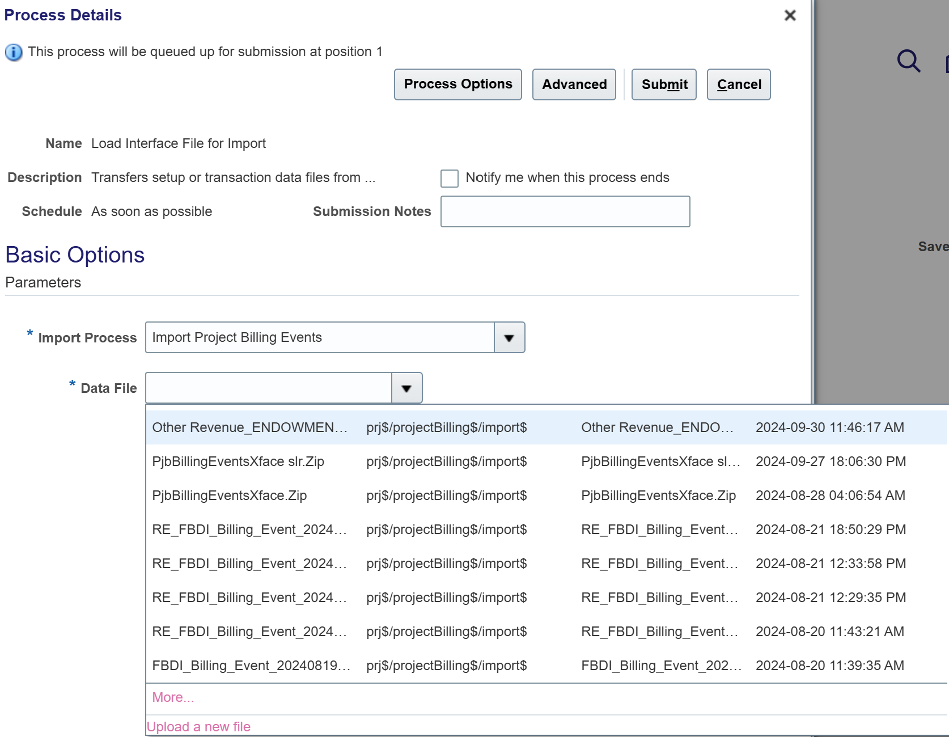
13
12

- Select the Choose File button.

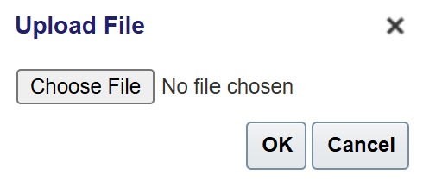
14

- Navigate to the file location and select it, then select the Open button.

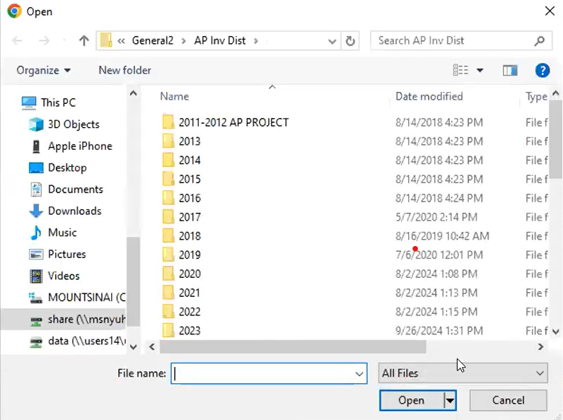
15

- Select the OK button.

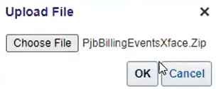
16

- Select the Submit button.

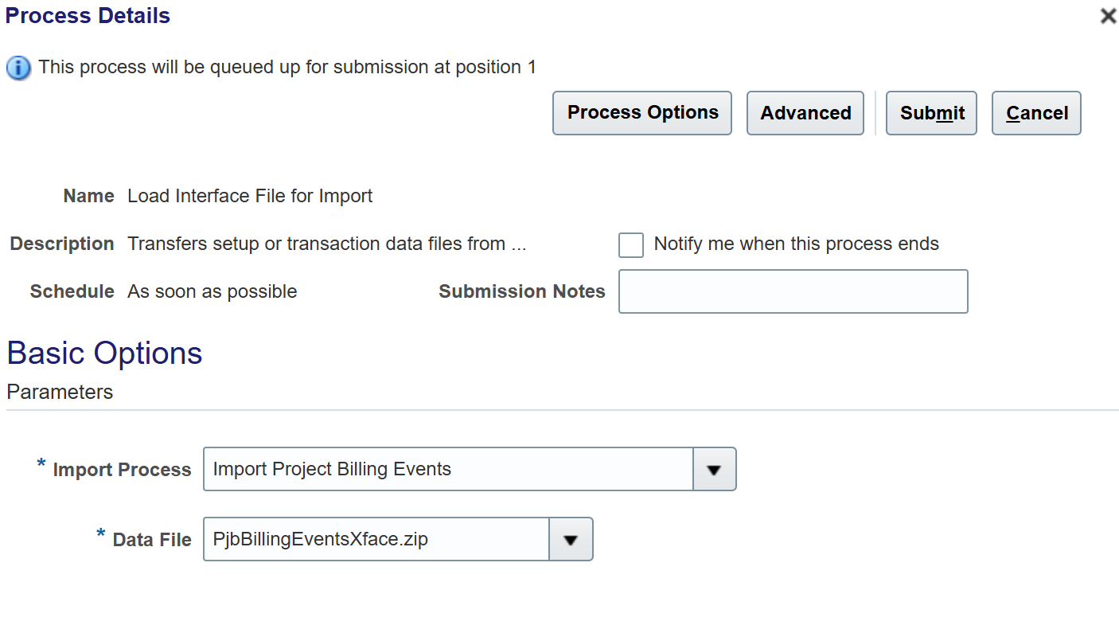
17

- Select the OK button.

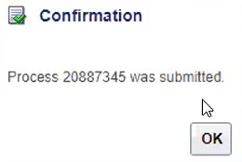
18

- Select the Refresh icon until the Load File to Interface status changes to Succeeded.
- Select the Schedule New Process button.

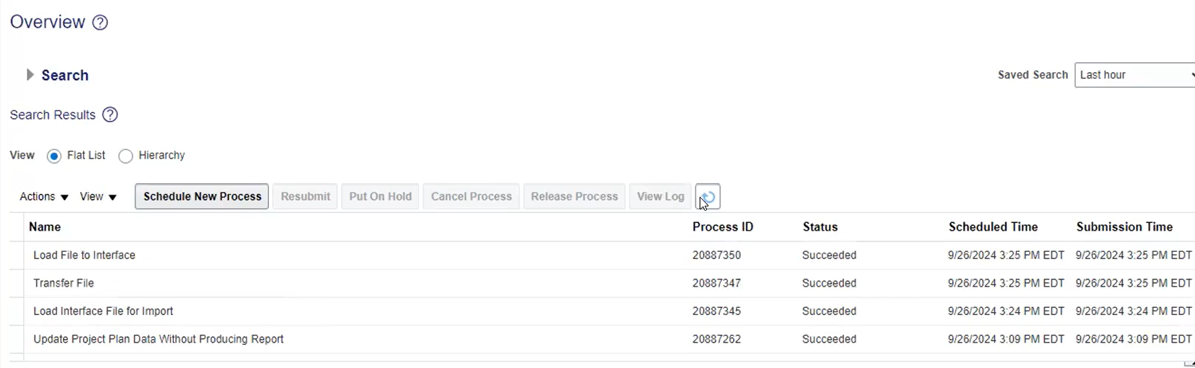
20
19

- Select the drop-down arrow and select Import Project Billing Events from the list.
- Select the OK button.
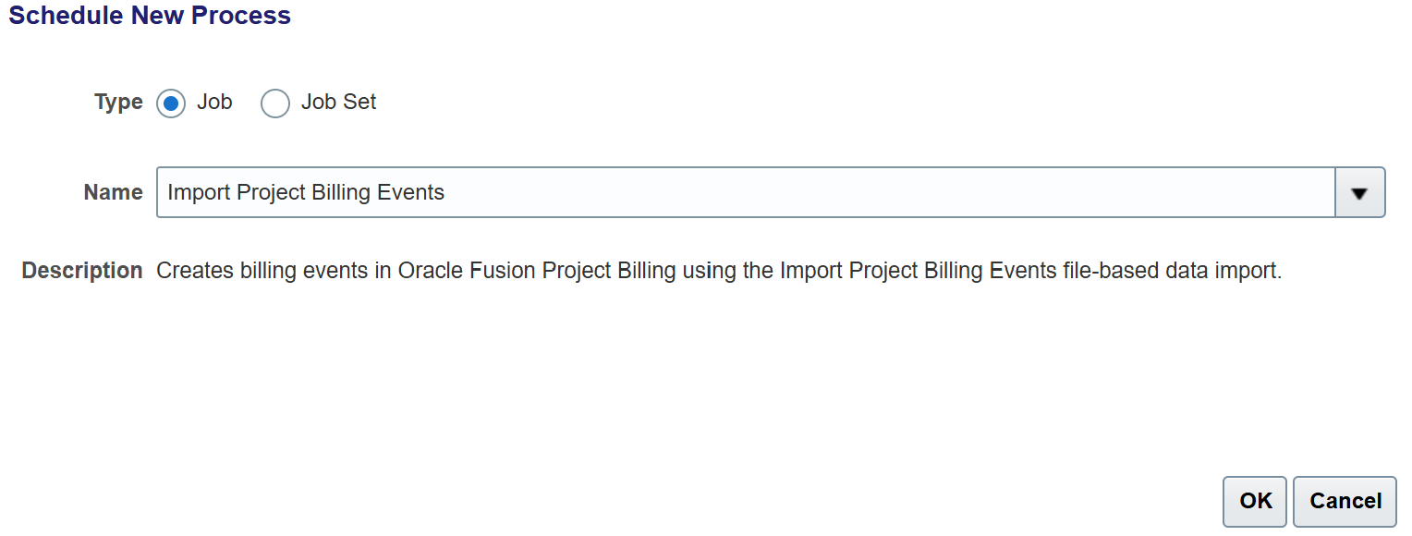
21
22

Please note: You may need to use the Search feature after selecting the drop-down arrow to find the import project billing events line item.

- Select the Submit button.
23
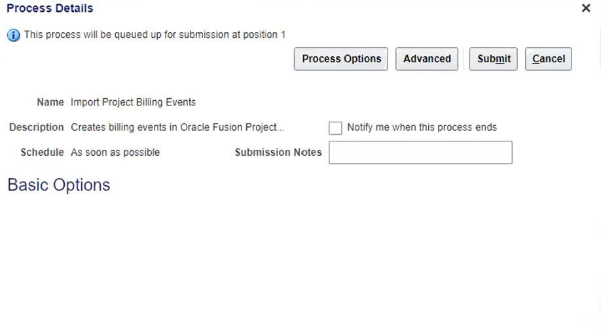

- Select the OK button.

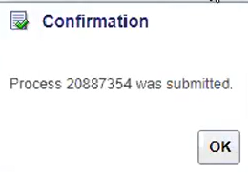
24

- Select the Refresh icon until the Import Project Billing Events and Imkport Project Billing Events: Generate Report statuses changes to Succeeded.
- Highlight the Generate Report line item and scroll to the bottom of the screen.
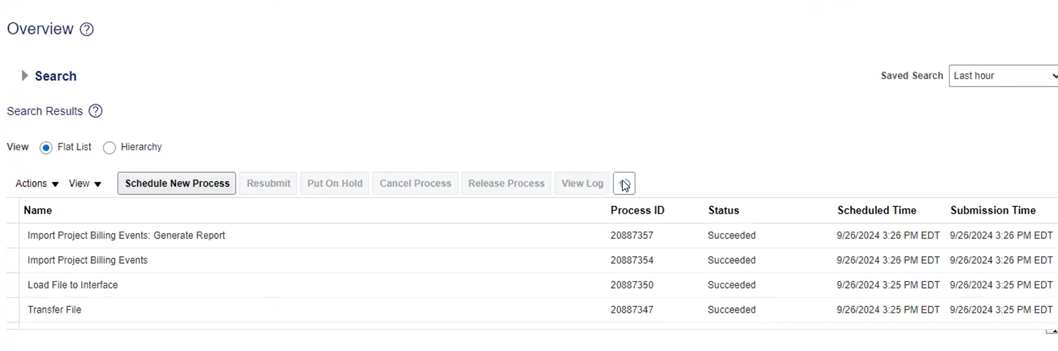
26
25

- Select the Republish icon.

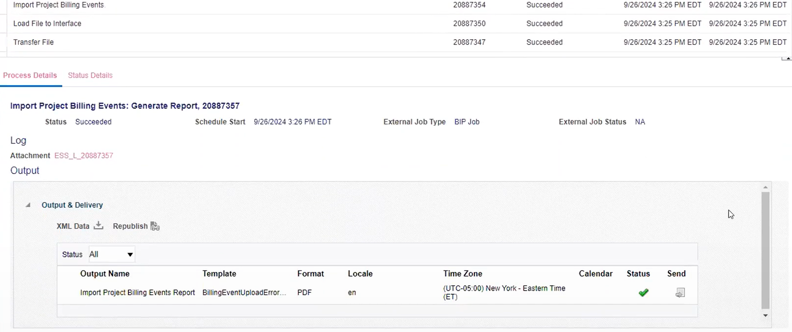
27

- Select the Folder icon and select PDF.

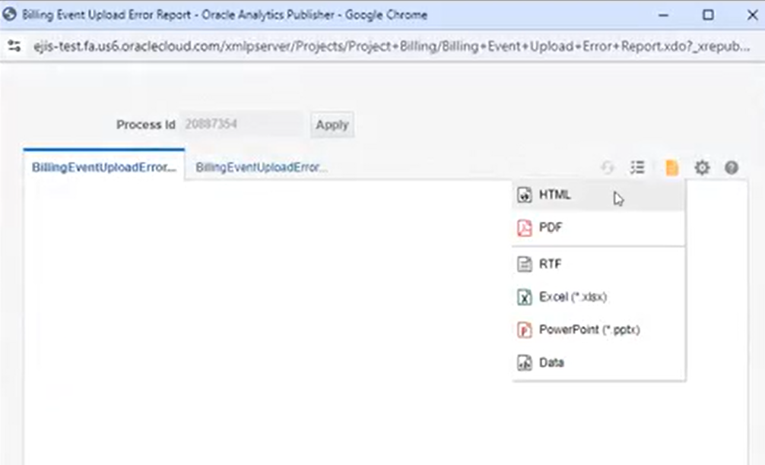
28

- The number of creation attempts matches the number of events created signifies no errors in processing. This transaction has been completed.

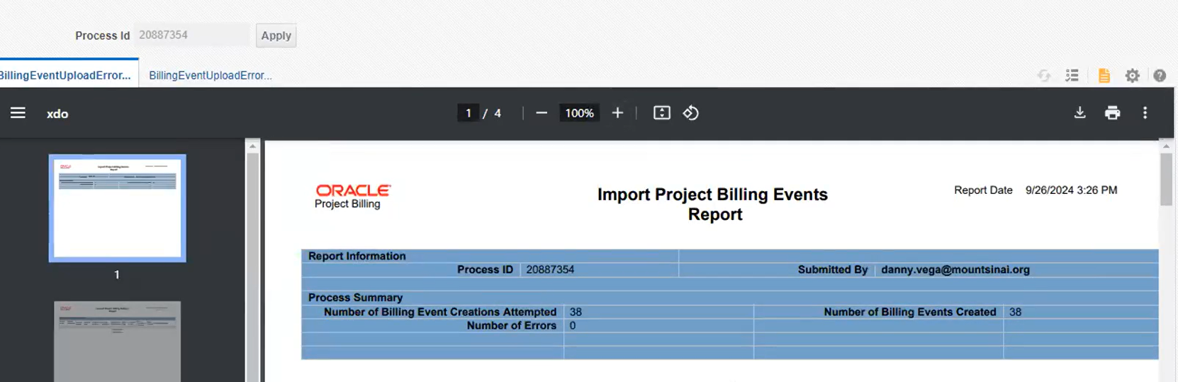
29

Manage Expenses Upload

- In the Menu Ribbon, select Projects.
- Select Costs.
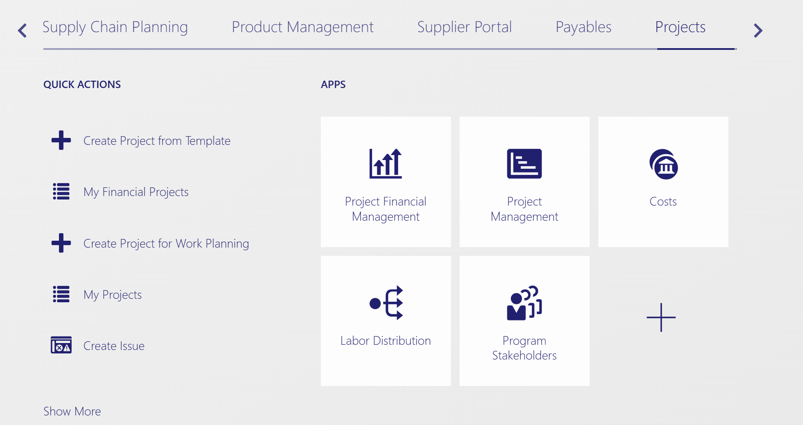
2
1

- On the Overview page, select the Task icon, then select the Capture Costs link in the Capture section.

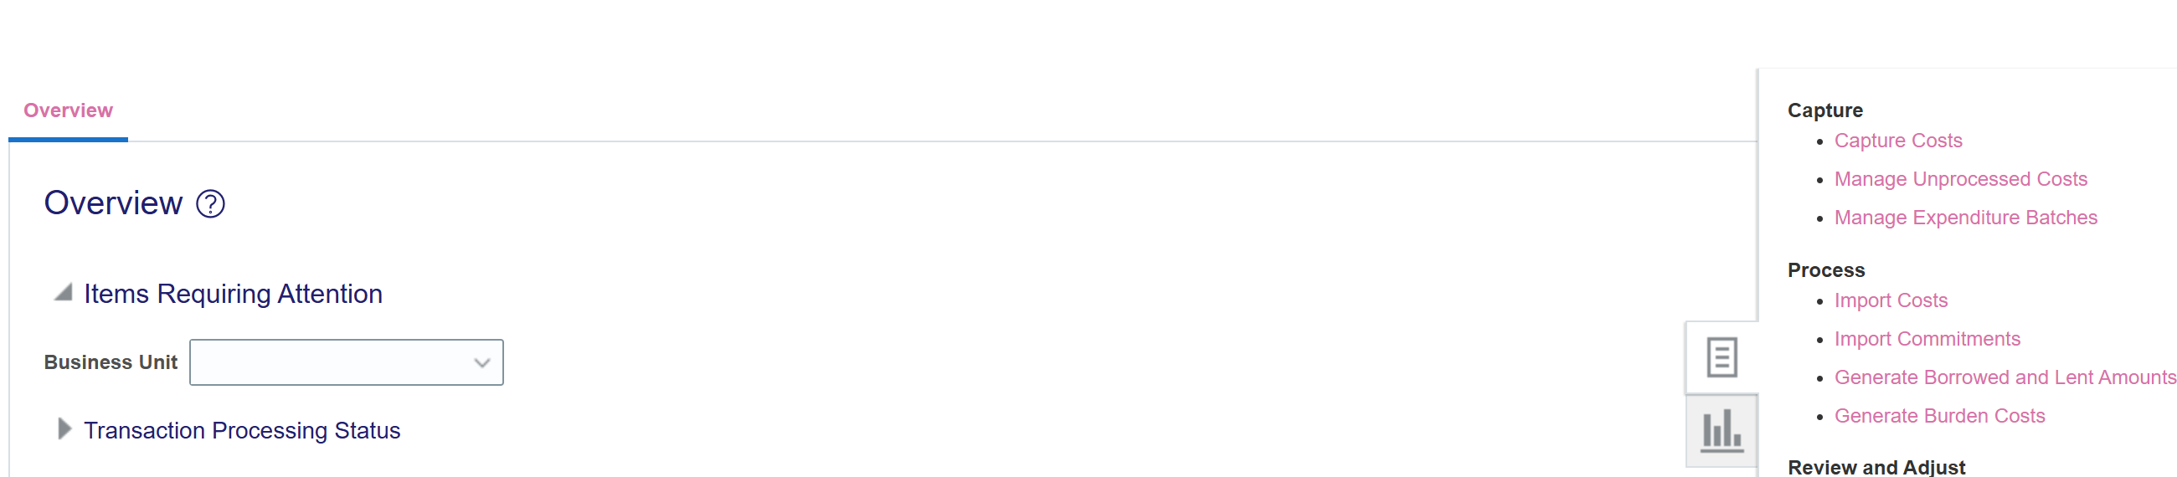
3

- In the Capture Costs window, select the Create Nonlabor Costs link.

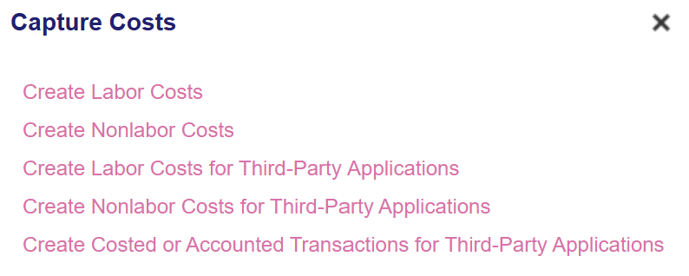
4

- Select the Open file link.

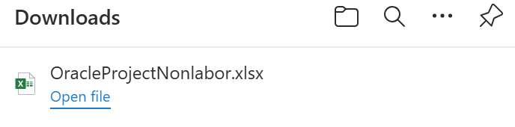
5

- Select the Enable Editing button.

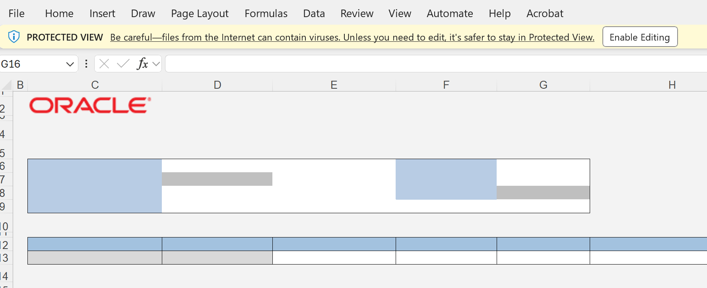
6

- Select the Yes button to continue.

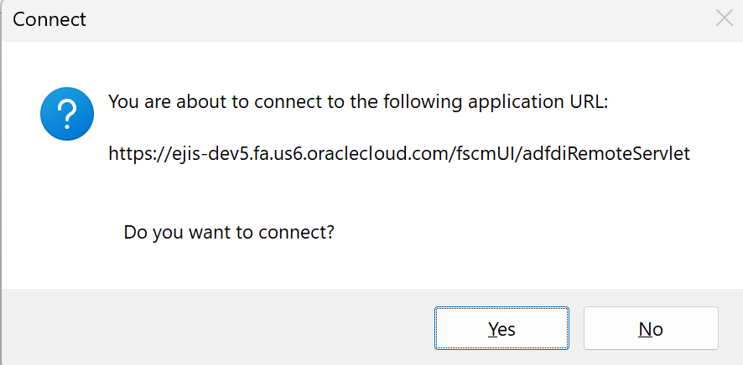
7

- Complete the following required fields:
- Business Unit
- Source
- Document
- Expenditure Batch

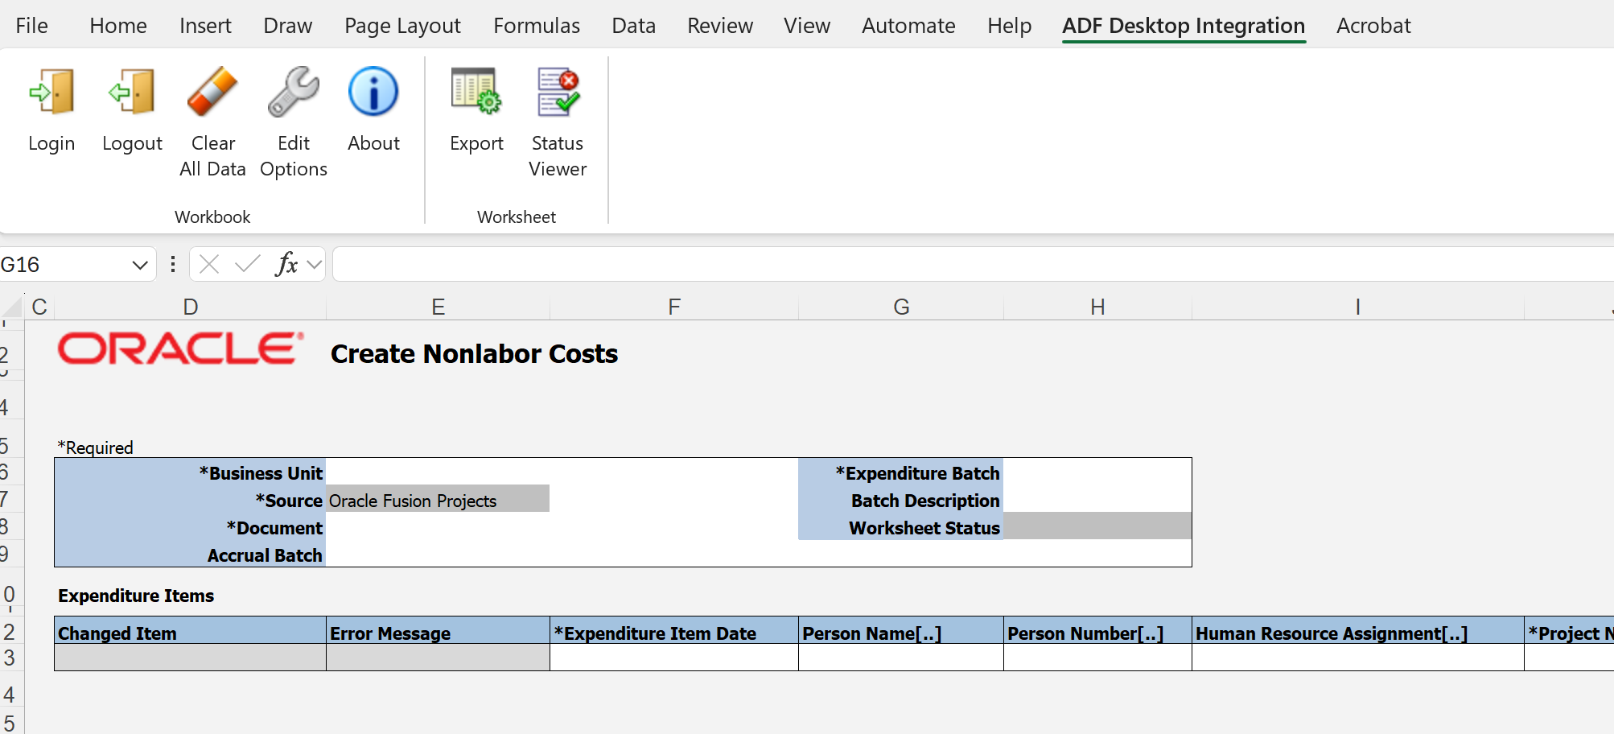
8

- Complete the following required fields:
- Expenditure Item Date
- Project Name
- Project Number
- Task Name (Enter Default)
- Task Number
- Expenditure Type
- Expenditure Organization
- Quantity (Dollar Amount)
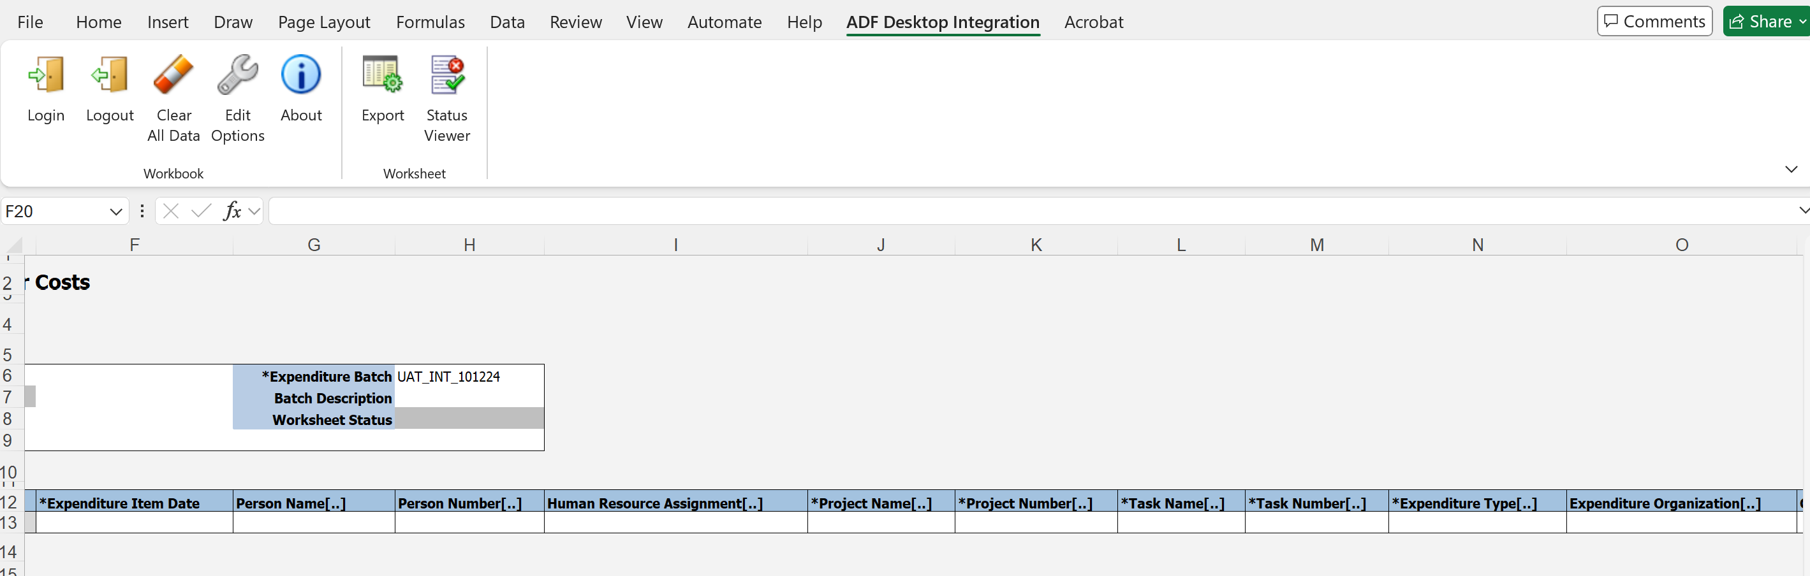
9

Please note: Insert as many rows as required to accommodate additional items. Be sure to remove any blank rows that are not used prior to exporting.

Please note: For line items with a negative quantity, select Yes in the Unmatched Negative Item column for that line item.

- Select the Status Viewer icon to check for any errors. Select the Export icon.
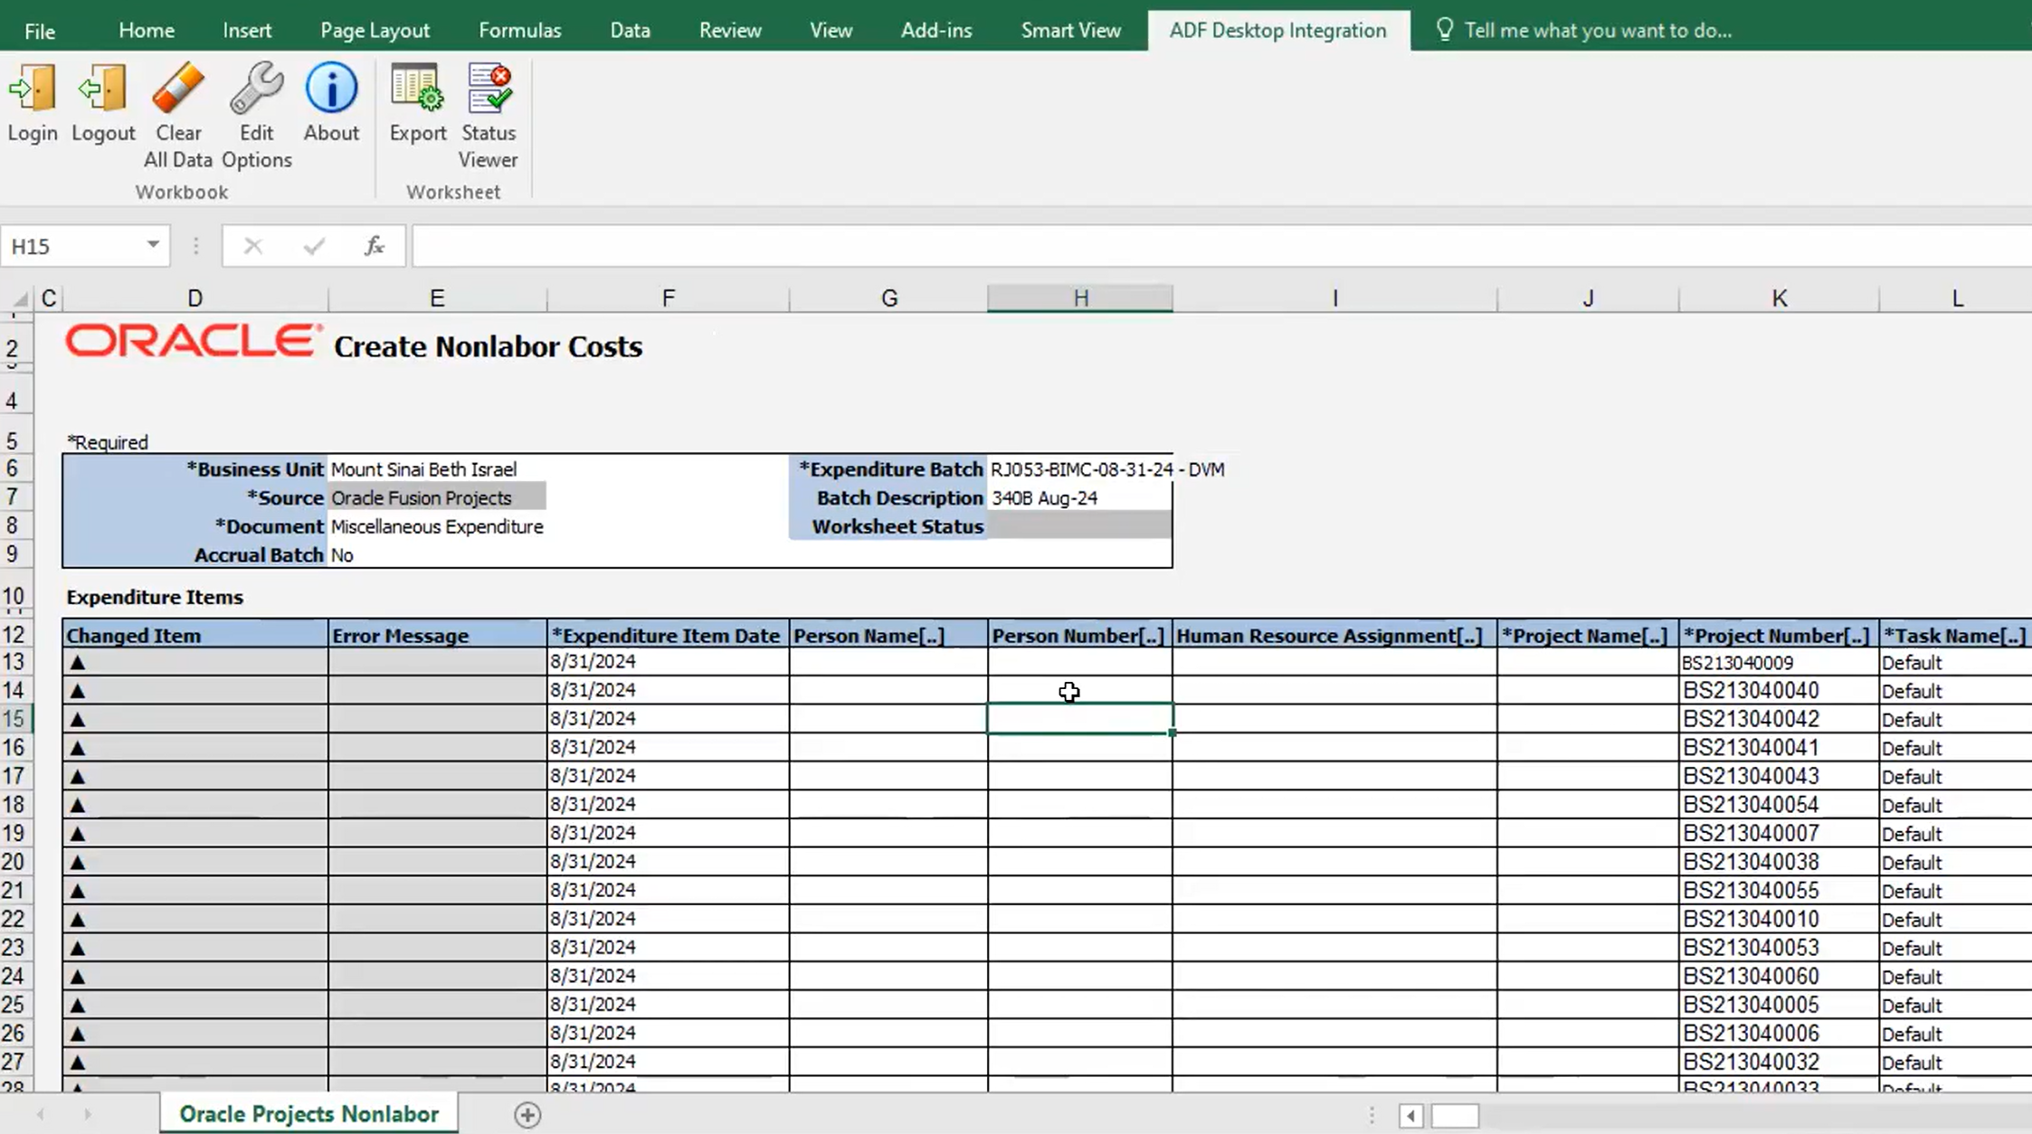
10

- Select the OK button.

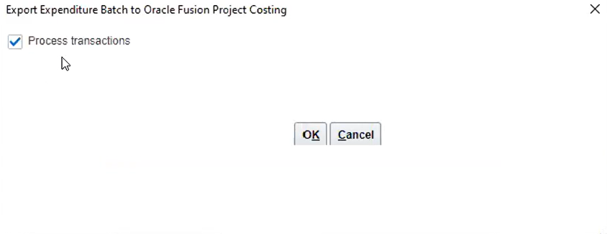
11

- Select the OK button in the Summary window.

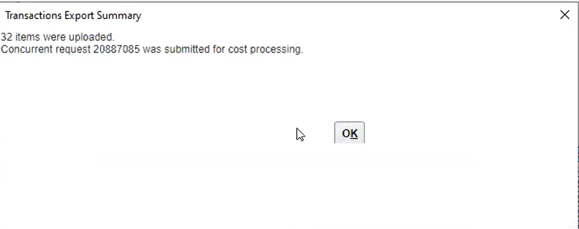
12

- Copy the name in the Expenditure Batch field and access Sinai Cloud to continue.

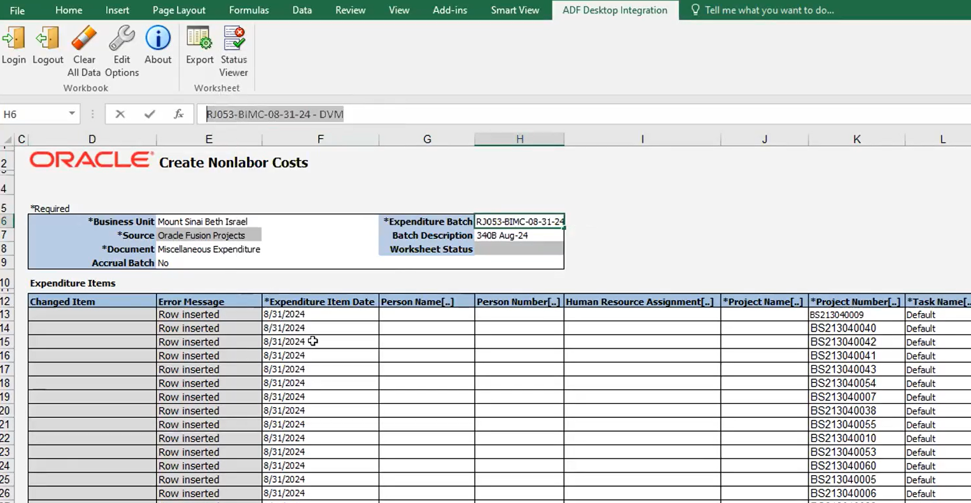
13

- In the Menu Ribbon, select Projects.
- Select Costs.
15
14

- On the Overview page, select the Task icon, then select the Manage Project Costs link in the Review and Adjust section.

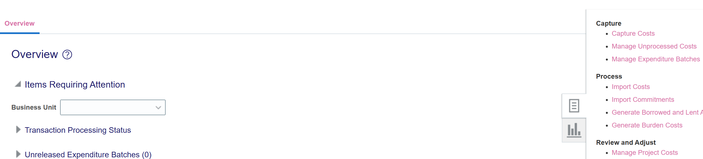
16

- Select the Advanced button.
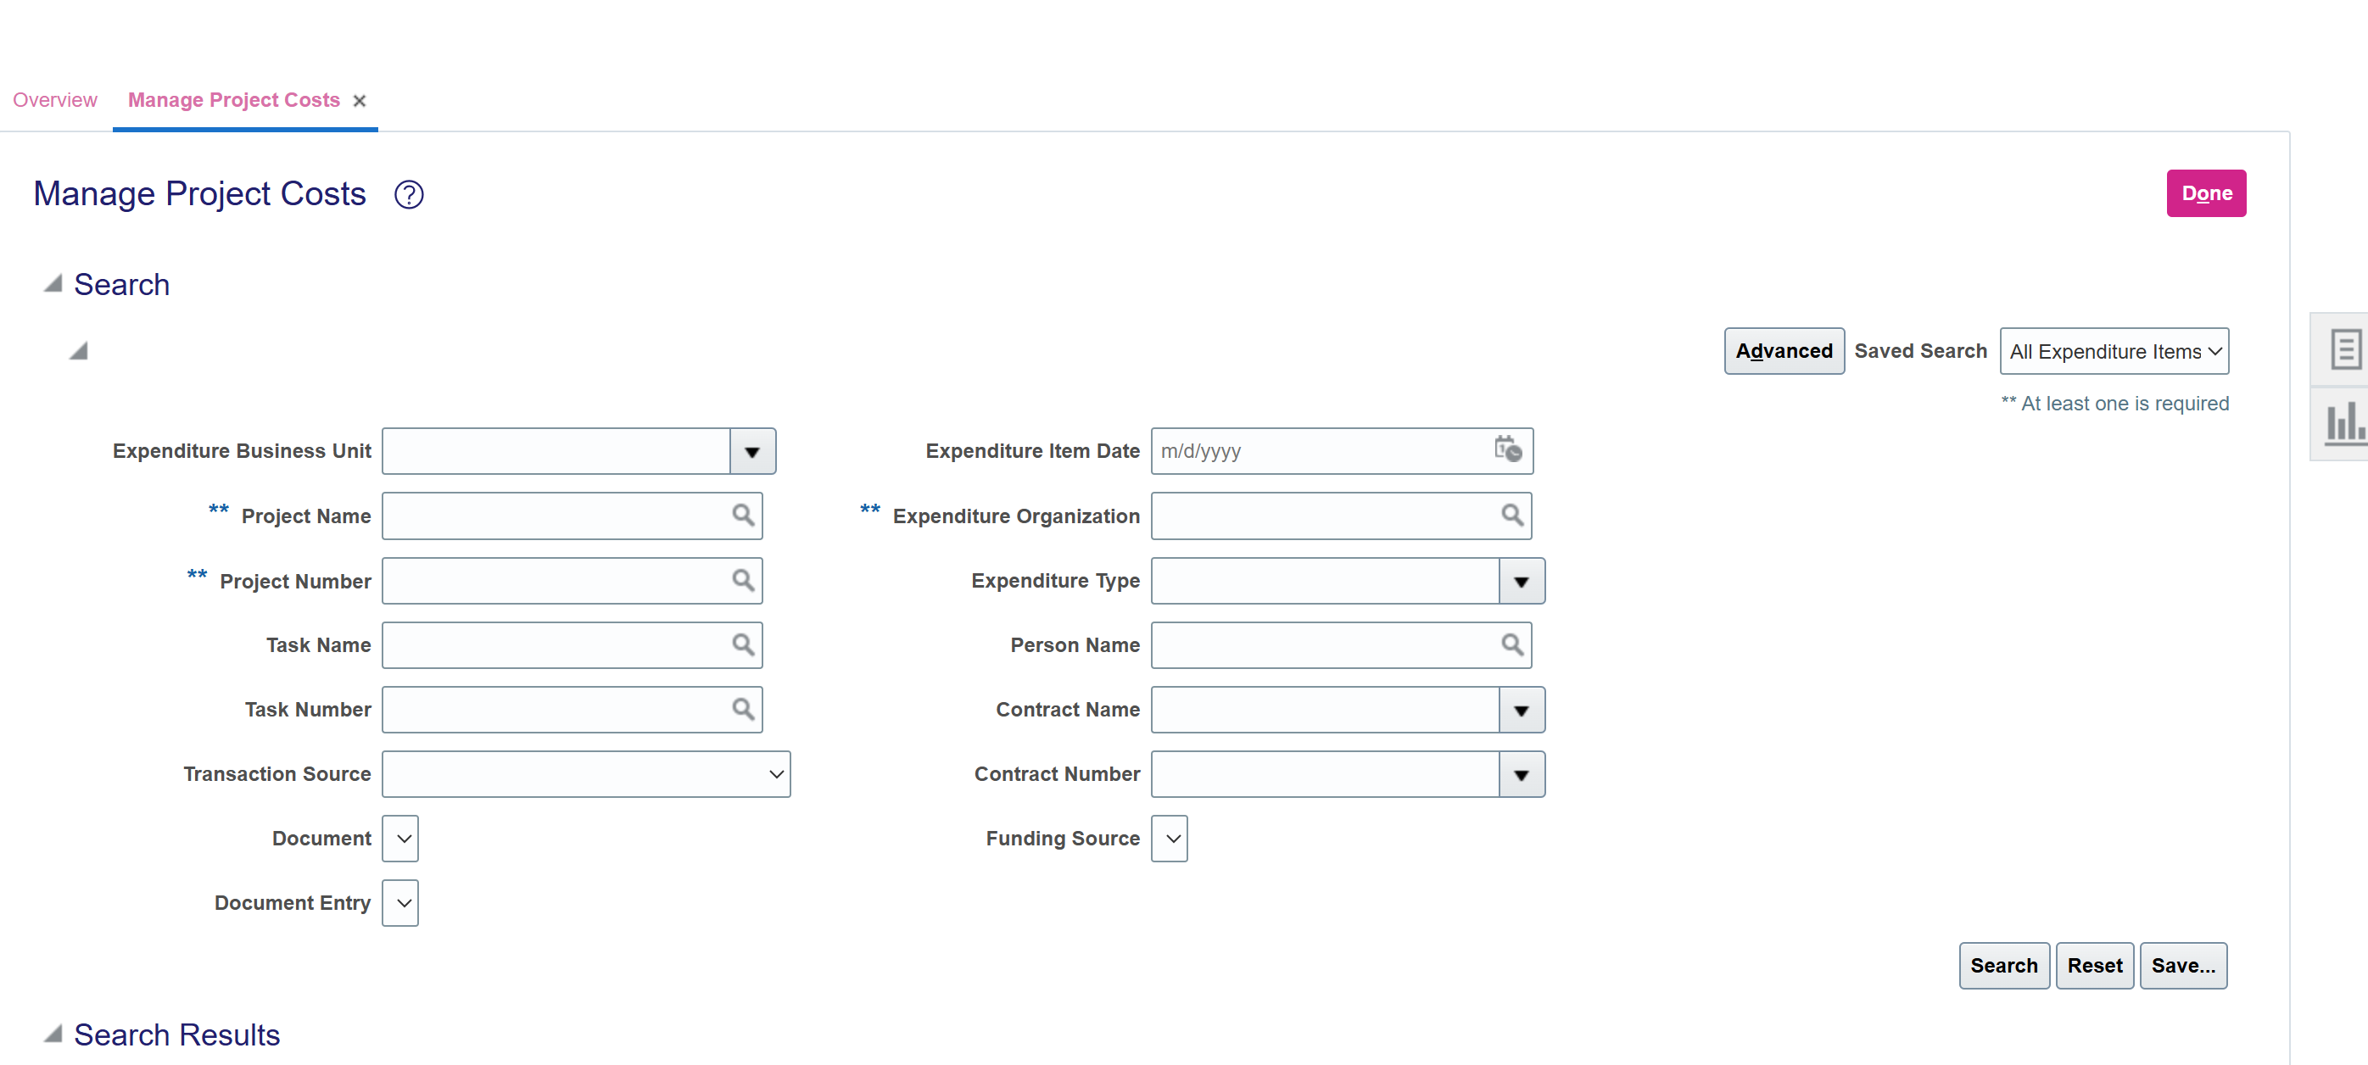
17

- In the Expenditure Batch field, select the drop-down and change the value to Starts with. Then enter the expenditure batch name in the blank field.
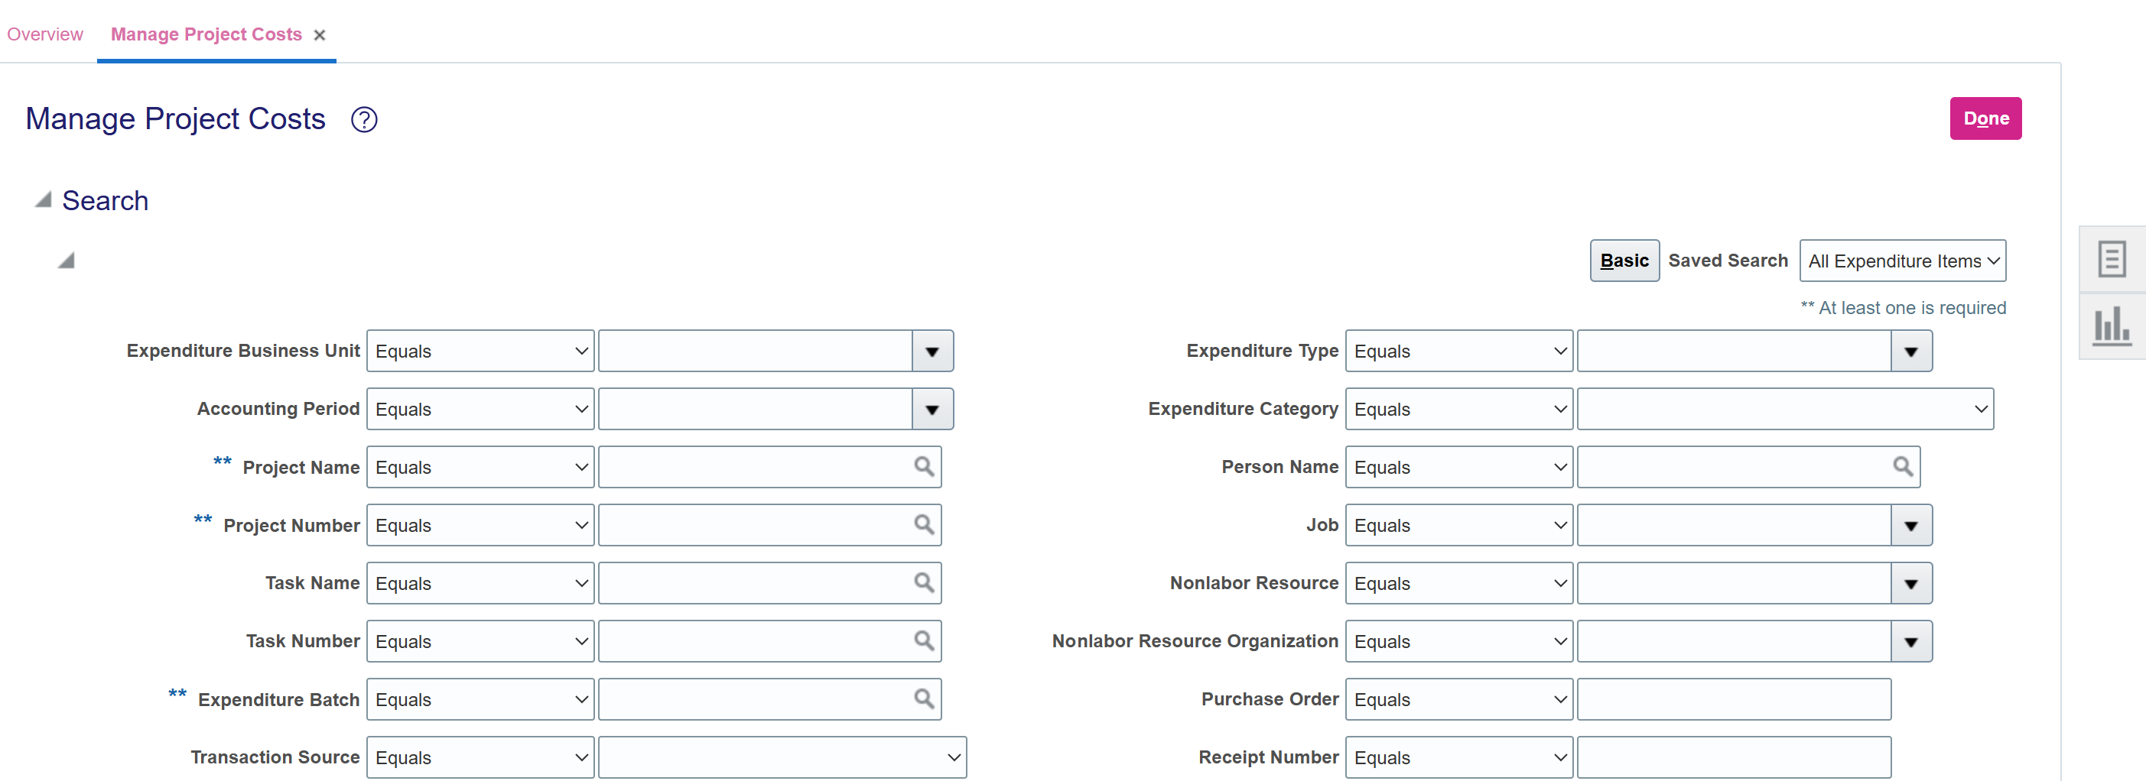
18

- Select the Search button.
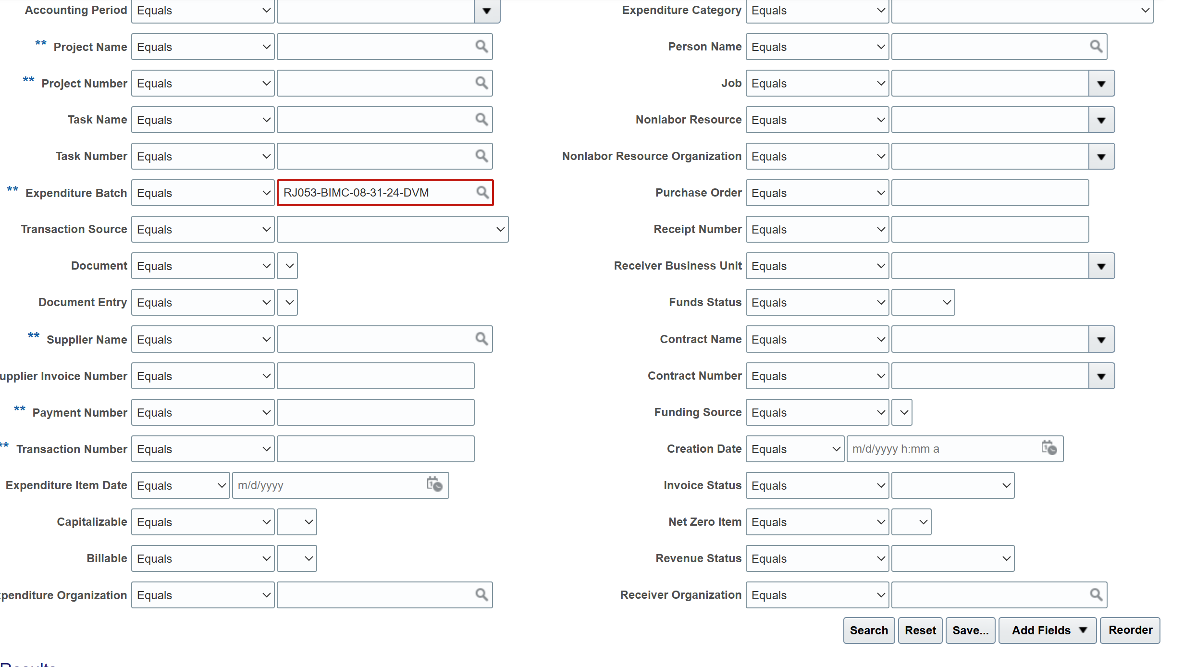
19

- Review the postings to ensure all events have been uploaded accordingly. Select the Done button. This transaction has been completed.

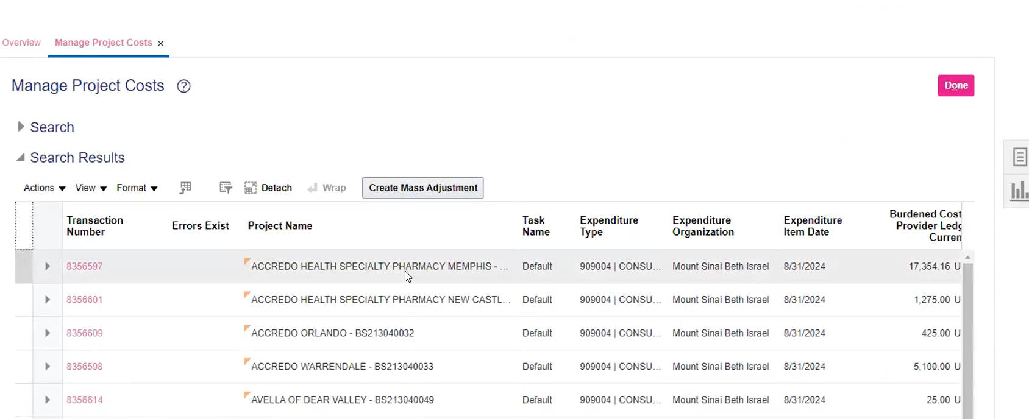
20

